*Florida International University*

*School of Computing and Information Sciences*

Software Engineering Focus

Feature Document

User Story ID <822>

**Name: Carlos Martinez**

**Team Member(s): Mairim Barrios, Arelys Alvarez, Fidel Hernandez, Samira Tellez**

**Project:ARVRVE-Senior Project**

**Product Owner(s)**: Dr. Francisco Orega

**Mentor(s)**:

**Instructor**: Masoud Sadjadi

**User Story Name: Add finishing touches to movement animation**

* Description: As a developer I would like to have it so that the character when moving around does so smoothly so that the user never notices any jerky movement.

Acceptance Criteria

* Character moves smoothly through maze
* Character turns smoothly

**Use Case**

* Name: User moves character
* Actor:User
* Preconditions: User adds commands and presses play
* Description User adds commands to command holder and presses play, character then moves around with the walking animation looking smooth:

**Use Case Diagram**

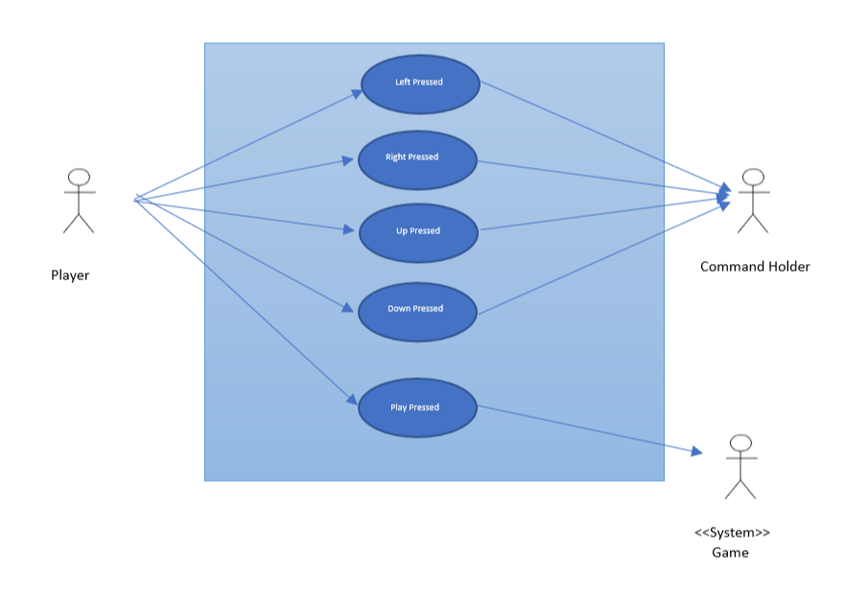

**Sequence Diagram**

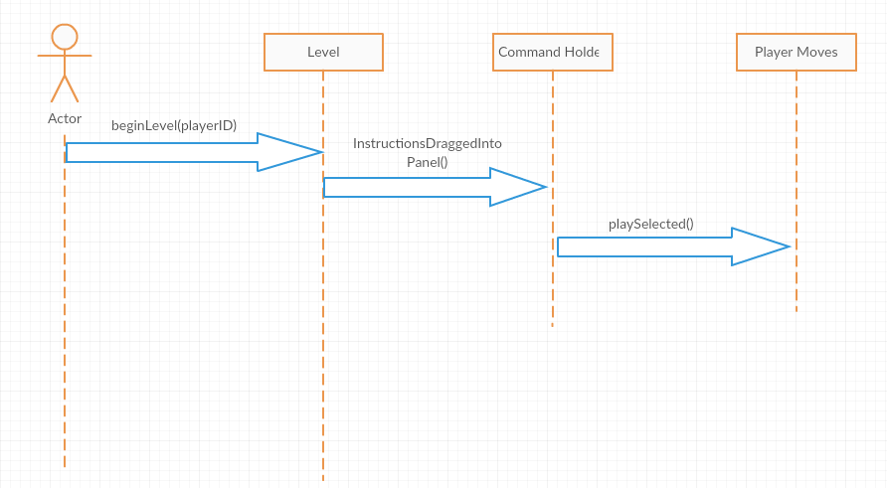

**Class Diagram**

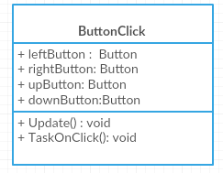

User Story ID <823>

**Name: Carlos Martinez**

**Team Member(s): Mairim Barrios, Arelys Alvarez, Fidel Hernandez, Samira Tellez**

**Project:ARVRVE-Senior Project**

**Product Owner(s)**: Dr. Francisco Orega

**Mentor(s)**:

**Instructor**: Masoud Sadjadi

**User Story Name: Continue working on moving past illusion gap**

* Description: **As a developer I would like to have it so that the user can move through the whole maze and not realize that the maze is an illusion**

Acceptance Criteria

* Have the character move smoothly across the maze

**Use Case**

* Name: User advances past maze “gap”
* Actor: Player
* Preconditions: User is about to traverse past the illusion part of the stage
* Description <Player inputs commands to move character past illusion and the character does so without the player noticing the trick>:

**Use Case Diagram**

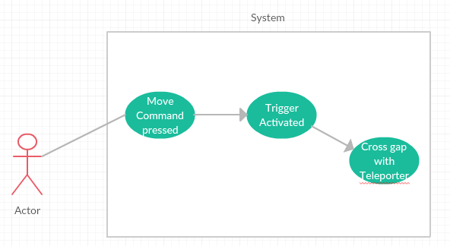

**Sequence Diagram**

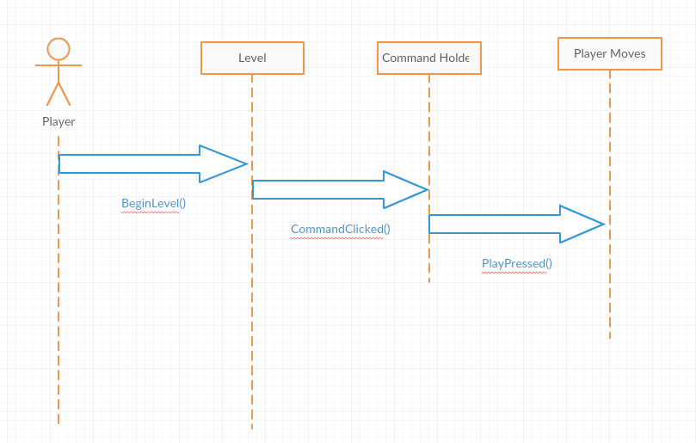

**Class Diagram**

